Yu-chuan Chen
Winter 2021
AH1003

Representing Endurance in Tang dynasty China

For centuries, Bactrian camels have been known for their adaptability and endurance. They can embark on long distance journey in a great variety of weather conditions without consuming any water for months. These qualities make them powerful and trustworthy companions for travelers, especially those engaged in caravan trade along the ancient Silk Road. The chosen ceramic sculpture (Figure 1) from VMFA dynamically glorifies the strength and endurance of Bactrian camels, depicted through its carefully modeled long legs, forward-looking head, and heavy goods on its humps.

[Paragraph 1] Discuss the long legs of the chosen camel.

[Paragraph 2] Discuss its forward-looking head.

[Paragraph 3] Discuss what are carried on its humps.

[Concluding paragraph]

This is only a suggested, skeleton model for you. Please feel free to modify, develop, and change the organization for your object. The rule of thumb for this short paper is to 1) create a thesis, 2) support it with visual evidences, 3) and be consistent with your thesis. And these are the three grading criteria.
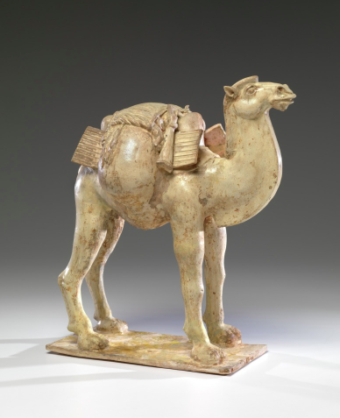
Figure 1: Bactrian Camel. 7th Century. China. 17 1/4 × 9 1/4 × 16 in. (43.82 × 23.5 × 40.64 cm). Earthenware with white glaze. Virginia Museum of Fine Art.

